**Project Report Format**

1. **INTRODUCTION** 
   1. **Project Overview:**

Citizen AI is an intelligent citizen engagement platform designed to revolutionize how governments interact with the public. Leveraging Flask, IBM Granite models, and IBM Watson, Citizen AI provides real-time, AI-driven responses to citizen inquiries regarding government services, policies, and civic issues. The platform integrates natural language processing (NLP) and sentiment analysis to assess public sentiment, track emerging issues, and generate actionable insights for government agencies. A dynamic analytics dashboard offers real-time visualizations of citizen feedback, helping policymakers enhance service delivery and transparency. By automating routine interactions and enabling data-driven governance, Citizen AI improves citizen satisfaction, government efficiency, and public trust in digital governance.

* 1. **Purpose:**
* Enable citizens to actively participate in governance by asking questions, submitting feedback, and reporting grievances through an AI assistant.
* Offer round-the-clock AI-powered support to guide citizens about government services, schemes, documents, and rights in a simple, conversational manner.
* Understand citizen emotions and concerns through sentiment analysis, helping authorities take meaningful and timely actions.

1. **IDEATION PHASE**
   1. **Problem Statement :**

Citizens often face difficulties in accessing public information, understanding government schemes, submitting feedback, and receiving timely responses due to the lack of intelligent, real-time, and inclusive platforms. There is a pressing need for a citizen-centric solution that enables transparent, accessible, and responsive governance through conversational AI, sentiment analysis, and real-time analytics.

* 1. **Empathy Map Canvas: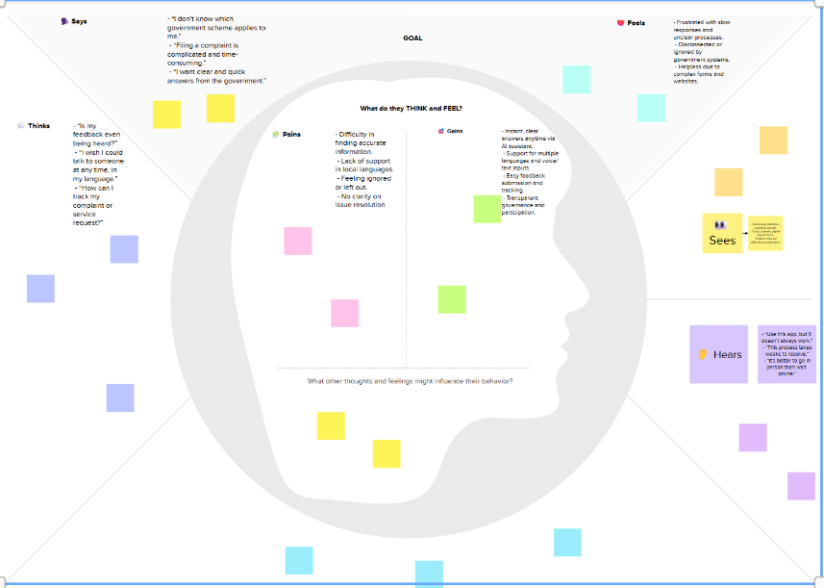as:**
  2. **Brainstorming:**

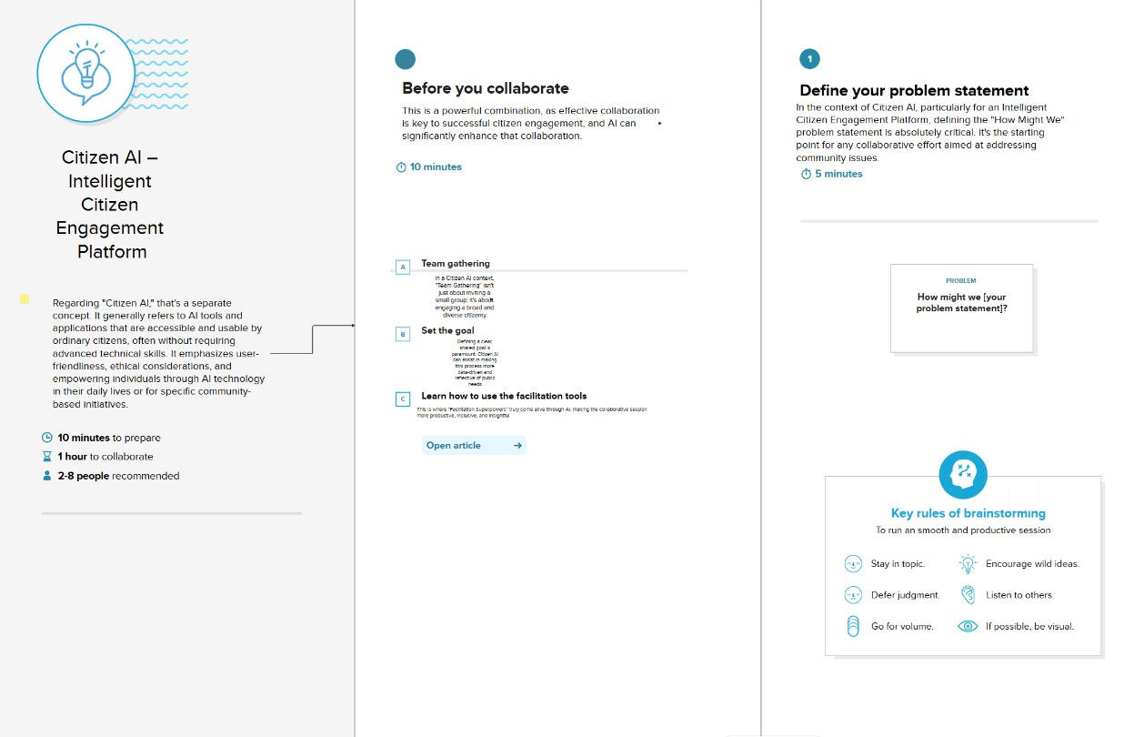

1. **REQUIREMENT ANALYSIS**
   1. **Customer Journey map:**

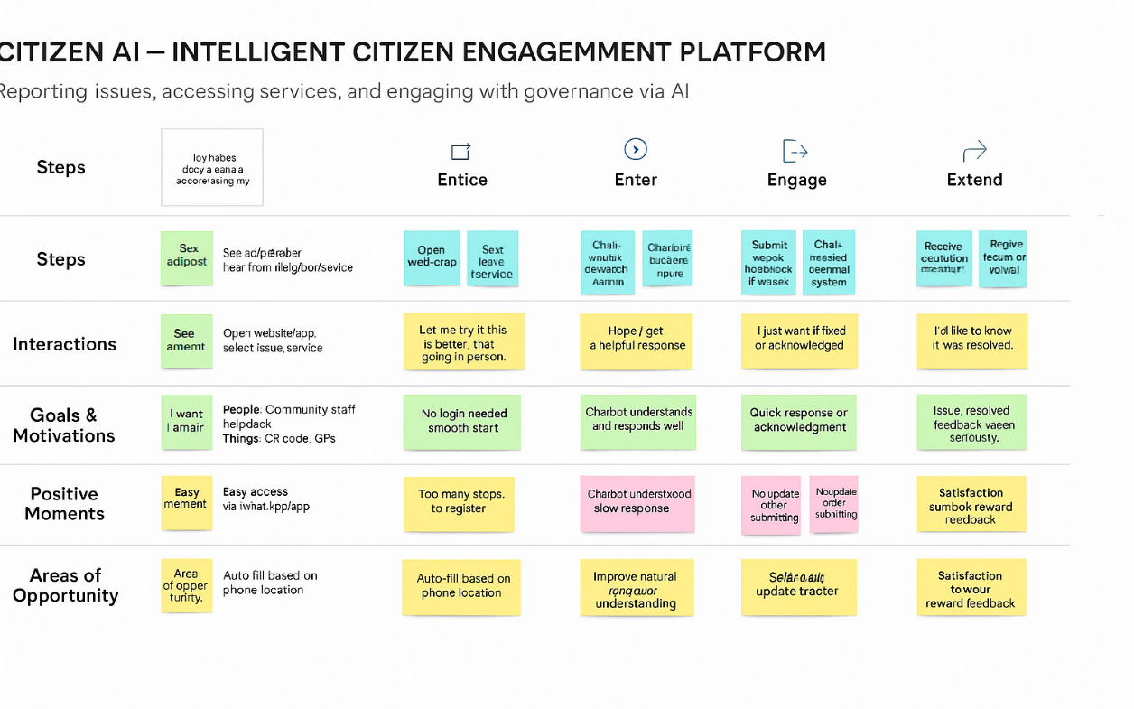

* 1. **Solution Requirement:**

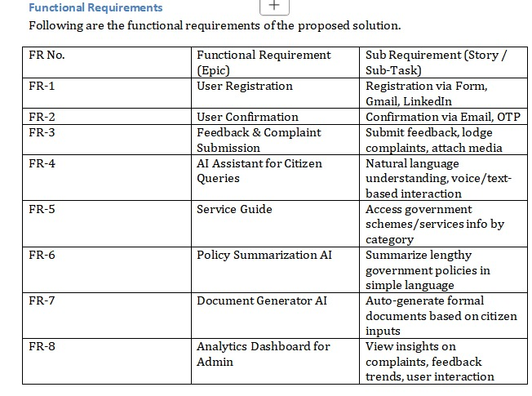

* 1. **Data Flow Diagram:**

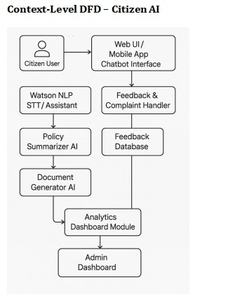

* 1. **Technology Stack :**

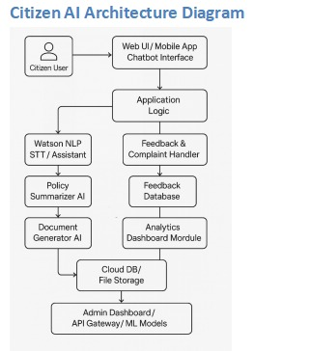

1. **PROJECT DESIGN** 
   1. **Problem Solution Fit :**

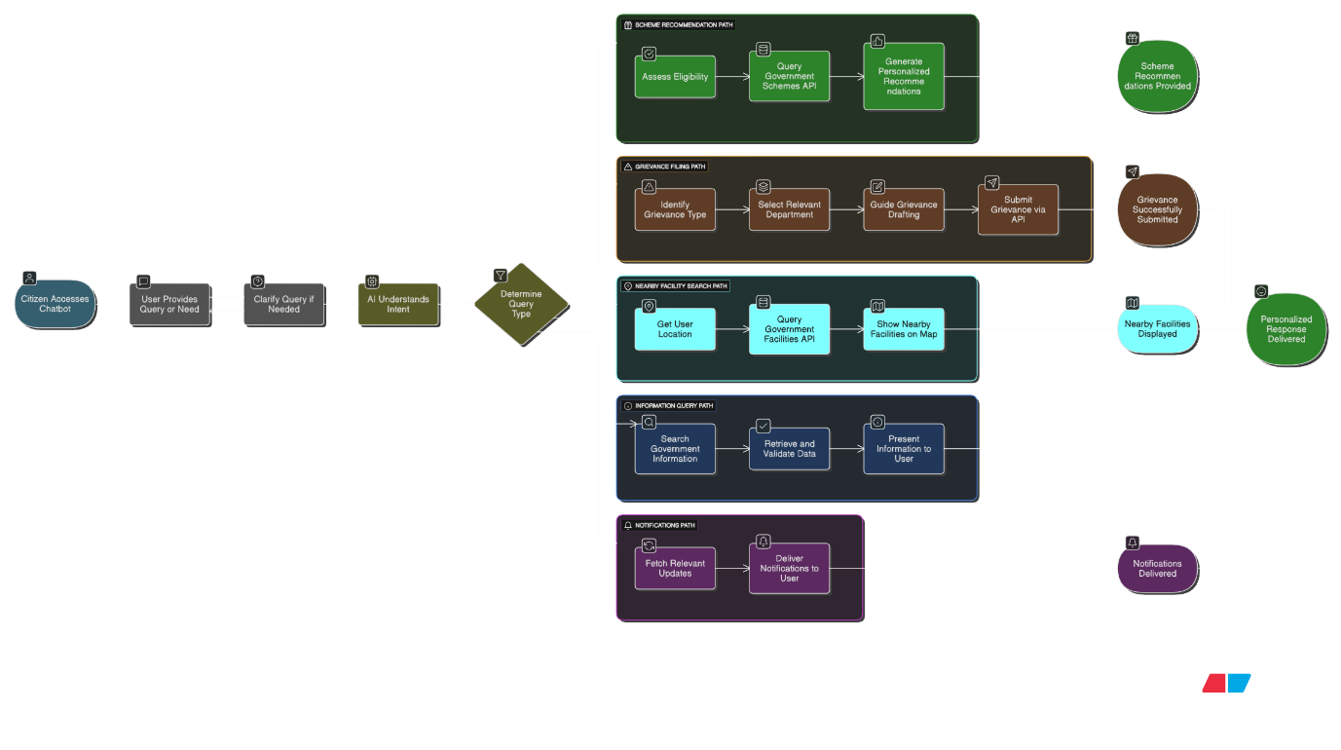

* 1. **Proposed Solution :**

|  |  |
| --- | --- |
| **Problem Statement (Problem to be solved)** | **Many citizens struggle to access relevant government services, policies, and schemes due to a lack of awareness, digital literacy, or fragmented platforms. This leads to low civic engagement and inequitable access to public benefits.** |
| **Idea / Solution description** | **Citizen AI is a conversational AI platform designed to bridge the gap between citizens and government services. By enabling natural language interactions in local languages, it provides personalized guidance on available schemes, grievance redressal systems, and civic rights—empowering users to take informed action in real time.** |
| **Novelty / Uniqueness** | **Unlike generic chatbots, Citizen AI leverages localized data, multilingual support, and sentiment understanding to offer context-specific responses. It adapts to regional issues and updates dynamically with policy changes, offering a personalized civic assistant experience.** |
| **Social Impact / Customer Satisfaction** | **Citizen AI improves inclusivity by reaching digitally underserved populations, strengthens democratic participation, and reduces bureaucratic friction. Pilots have shown increased awareness of entitlements and faster resolution of citizen grievances.** |
| **Business Model (Revenue Model)** | **Revenue can be generated through a B2G (business-to-government) model via platform licensing, customization services for municipalities, and long-term maintenance contracts. Potential exists for CSR-backed deployments and NGO partnerships as well.** |
| **Scalability of the Solution** | **The modular architecture and API-first design of Citizen AI support rapid rollout across states and languages. The platform is built to integrate seamlessly with e-Governance APIs and can expand into sectors like healthcare, education, and disaster response.** |

* 1. **Solution Architecture:**

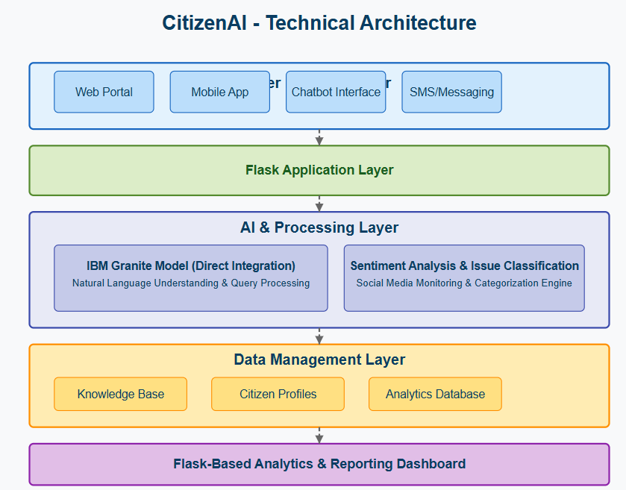

1. **PROJECT PLANNING & SCHEDULING** 
   1. **Project Planning :**

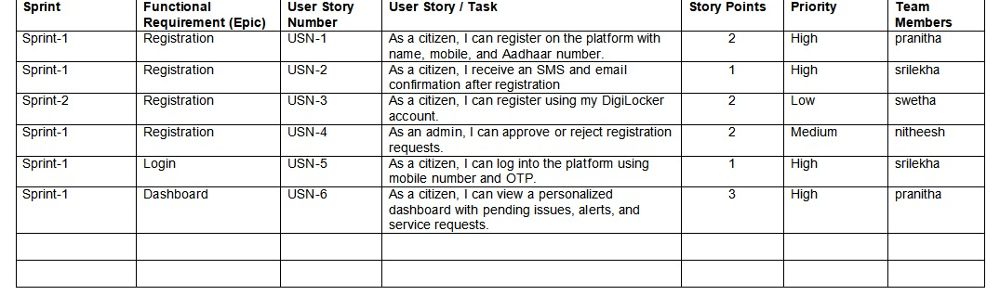

1. **FUNCTIONAL AND PERFORMANCE TESTING** 
   1. **Performance Testing :**

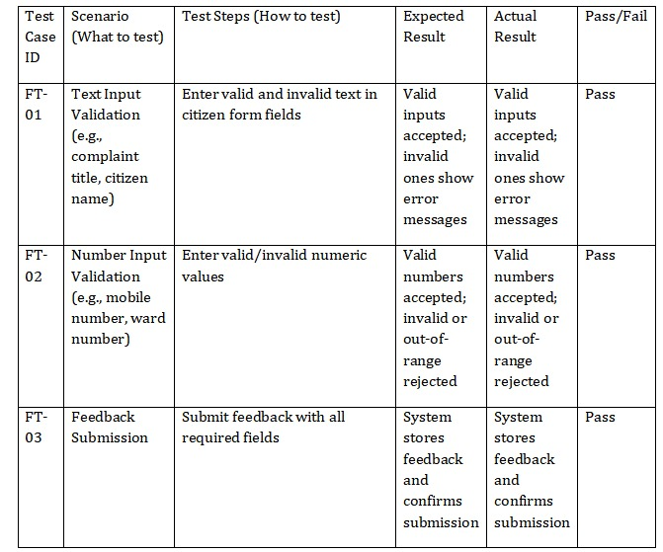

1. **RESULTS** 
   1. **Output Screenshots :**

**Real time ai-assistant:**

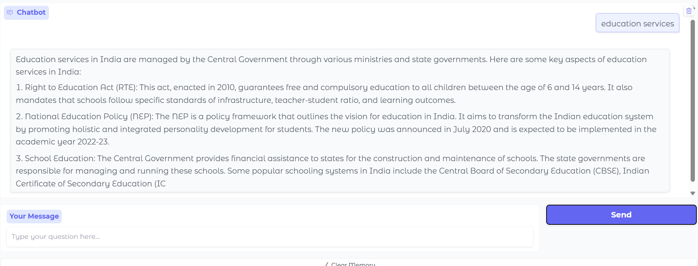

**Citizen dashboard:**

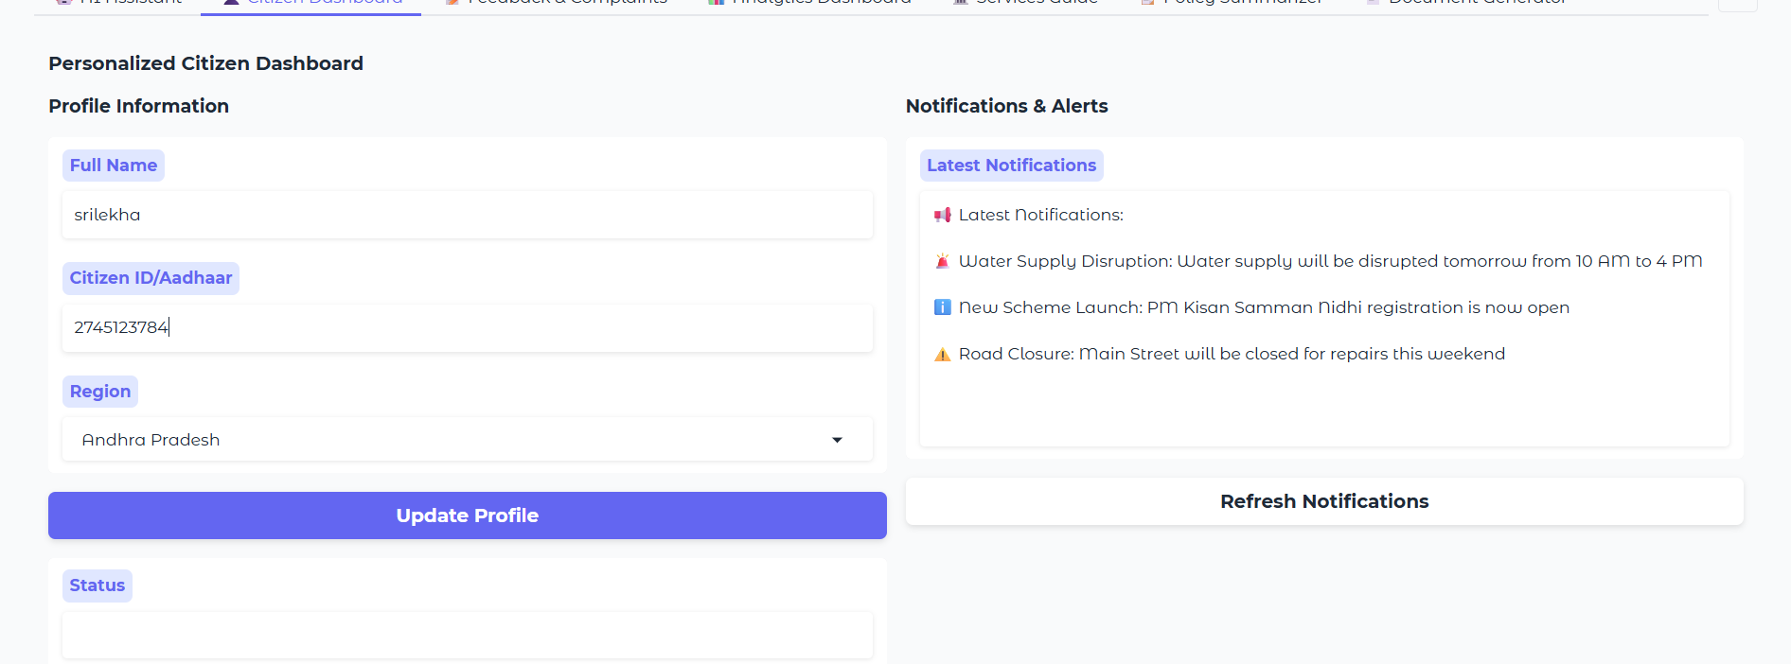

**Feedback and complaints:**

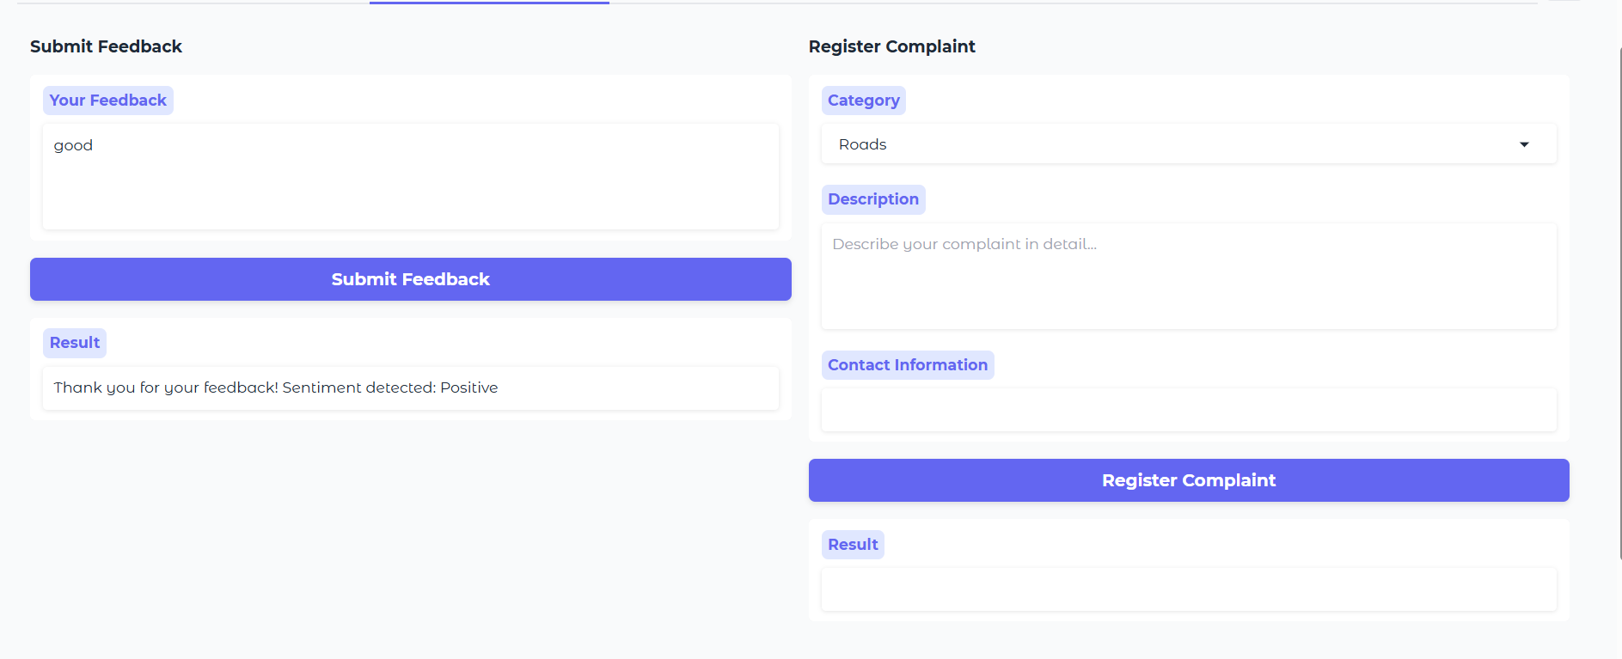

**Analytics Dashboard:**

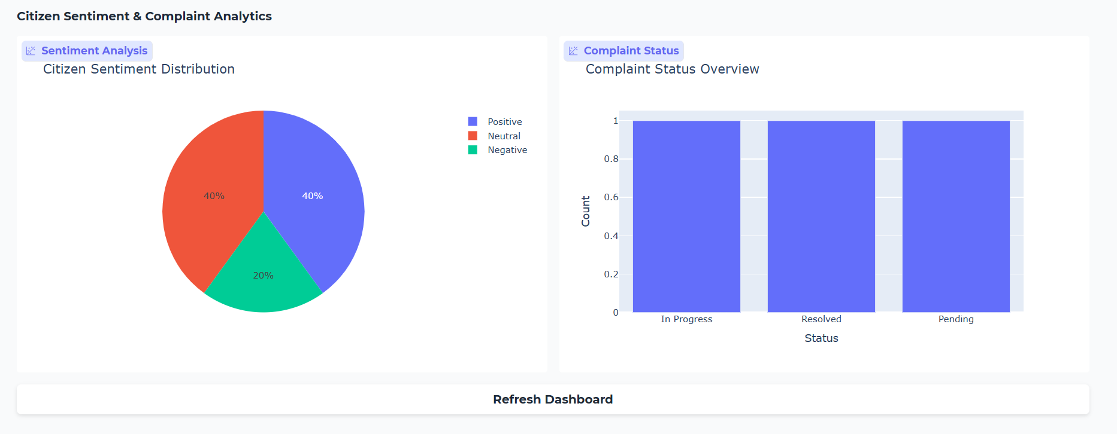

**Service Guide:**

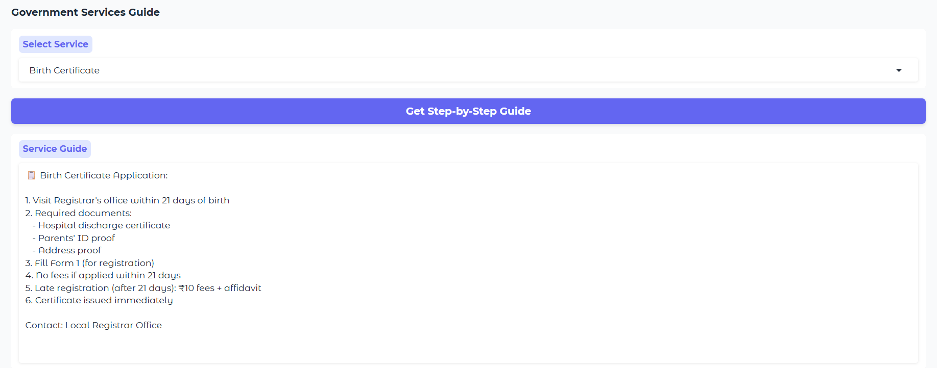

1. **ADVANTAGES & DISADVANTAGES**

**ADVANTAGES:**

**Advantages of Citizen AI (Point-wise)**

1. **24x7 AI Assistant** – Provides round-the-clock support for citizen queries.
2. **Multilingual Support** – Accessible in multiple regional languages and dialects.
3. **Simple Complaint System** – Citizens can easily submit feedback or complaints via chat.
4. **Sentiment Analysis** – Automatically detects emotions in complaints for priority handling.
5. **Policy Summarization** – Explains complex government policies in simple, easy-to-understand language.
6. **Real-Time Analytics** – Dashboards for authorities to monitor public sentiment and service usage.
7. **Two-Way Engagement** – Enables interactive communication between citizens and government.
8. **Remote Access** – Useful for rural citizens to access services online.
9. **Personalized Recommendations** – Suggests relevant schemes and services based on user profile.
10. **Supports Transparency** – Promotes open governance and trust among citizens.

**Disadvantages of Citizen AI (Point-wise)**

1. **Data Privacy Concerns** – Risk of misuse if citizen data is not properly secured.
2. **Digital Divide** – Excludes users without internet access or digital literacy.
3. **AI Misunderstanding** – Chatbot may misinterpret user queries or sentiments.
4. **Language Limitations** – May not support all dialects or accents accurately.
5. **Initial Development Cost** – Requires high upfront investment in AI and infrastructure.
6. **Dependence on Technology** – System failures or downtime can impact service.
7. **Lack of Human Touch** – May not fully replace human empathy in sensitive cases.
8. **Ongoing Maintenance** – Requires regular updates, bug fixes, and AI model training.
9. **Potential Bias** – AI may inherit biases from training data if not properly handled.
10. **User Resistance** – Some citizens may prefer traditional in-person interactions.
11. **CONCLUSION :**

The **Citizen AI – Intelligent Citizen Engagement Platform** is a transformative solution designed to bridge the gap between governments and citizens through the power of Generative AI. By integrating advanced AI models like **IBM Granite** with an intuitive and inclusive user interface, the platform enables real-time, multilingual interaction, transparent grievance redressal, and data-driven governance.

1. With modules such as the **Real-Time Conversational Assistant**, **Sentiment Analysis Engine**, **Dynamic Analytics Dashboard**, and **Personalized Service Guide**, Citizen AI empowers both **citizens** and **authorities** to engage in a smarter, faster, and more responsive civic ecosystem.

The platform not only simplifies access to public services but also strengthens trust in governance by promoting **accountability**, **transparency**, and **active public participation**. It’s designed with inclusivity at its core — supporting regional languages, accessibility features, and offline modes for rural or underserved populations.

As governments continue their digital transformation journeys, **Citizen AI stands as a scalable, secure, and citizen-first model** for smart governance. It sets a benchmark for how technology and empathy can come together to build a more informed, connected, and empowered society.

1. **FUTURE SCOPE:**

* **Integration with Government Portals & APIs**
* **Seamless connection with e-Governance platforms like DigiLocker, MyGov, UMANG, and local service delivery systems.**
* **• Voice-Enabled Virtual Assistants**
* **Deployment of voice bots via IVR or smart speakers for rural and elderly populations.**
* **• Multilingual Expansion with NLP**
* **Advanced support for all 22 Indian languages and dialects using better Natural Language Processing.**
* **• AI-Driven Personalized Governance**
* **Hyper-personalized alerts, scheme eligibility checks, and document guidance based on citizen profiles.**
* **• Sentiment-Based Policy Reforms**
* **Public sentiment data used to inform and reform policies, enhancing participatory democracy.**

**12.APPENDIX**

GitHub Link: <https://github.com/srilekhadronadula/citizenai>

Demo video Link: https://drive.google.com/file/d/1_hH7heXPRDoqBguDOm5Q2LE-HdWff2RP/view?usp=sharing